Prasar Srivastava  
22BCE10841  
AWS Solution Lab2

STEPS TO CREATE IAM ROLE AND ASSIGN TO IAM USER WITH POLICIES

STEP1: GO TO CONSOLE PAGE AND CLICK ON IAM

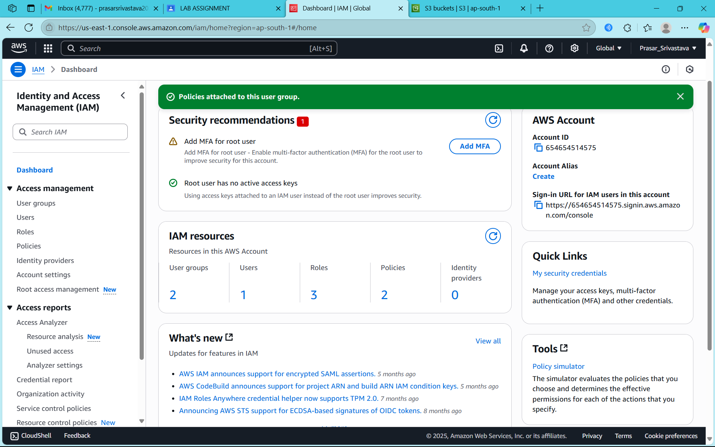

STEP2: GO TO ROLES FROM IAM DASHBOARD AND CLICK ON CREATE ROLE

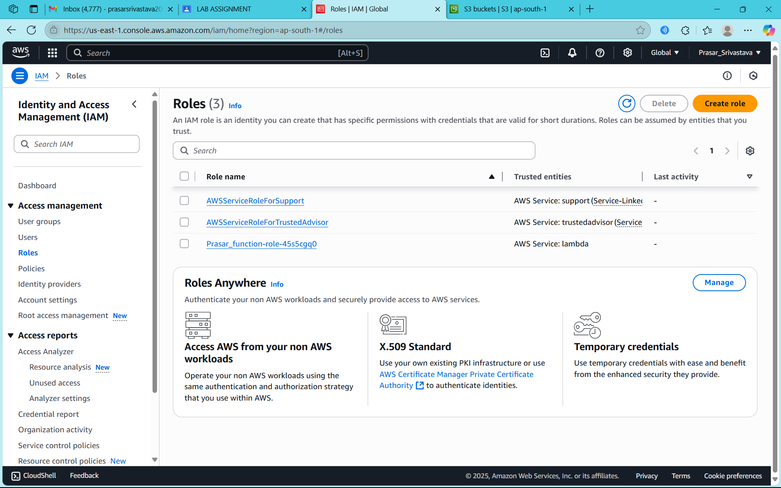

STEP3: SELECT AWS ACCOUNT

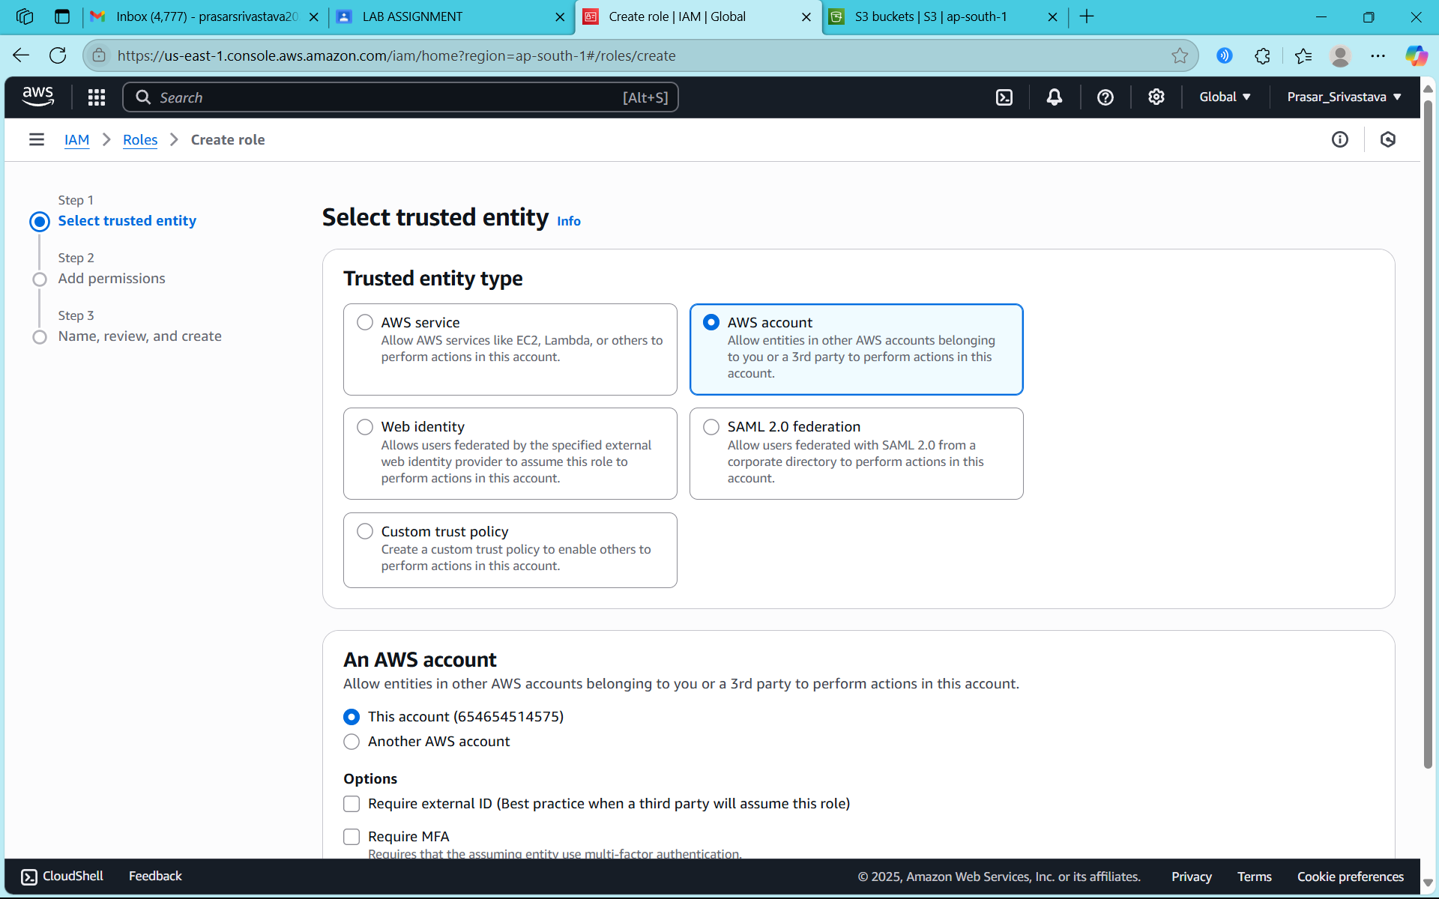

STEP4: CHOOSE ROOT ACCOUNT AND CLICK ON NEXT

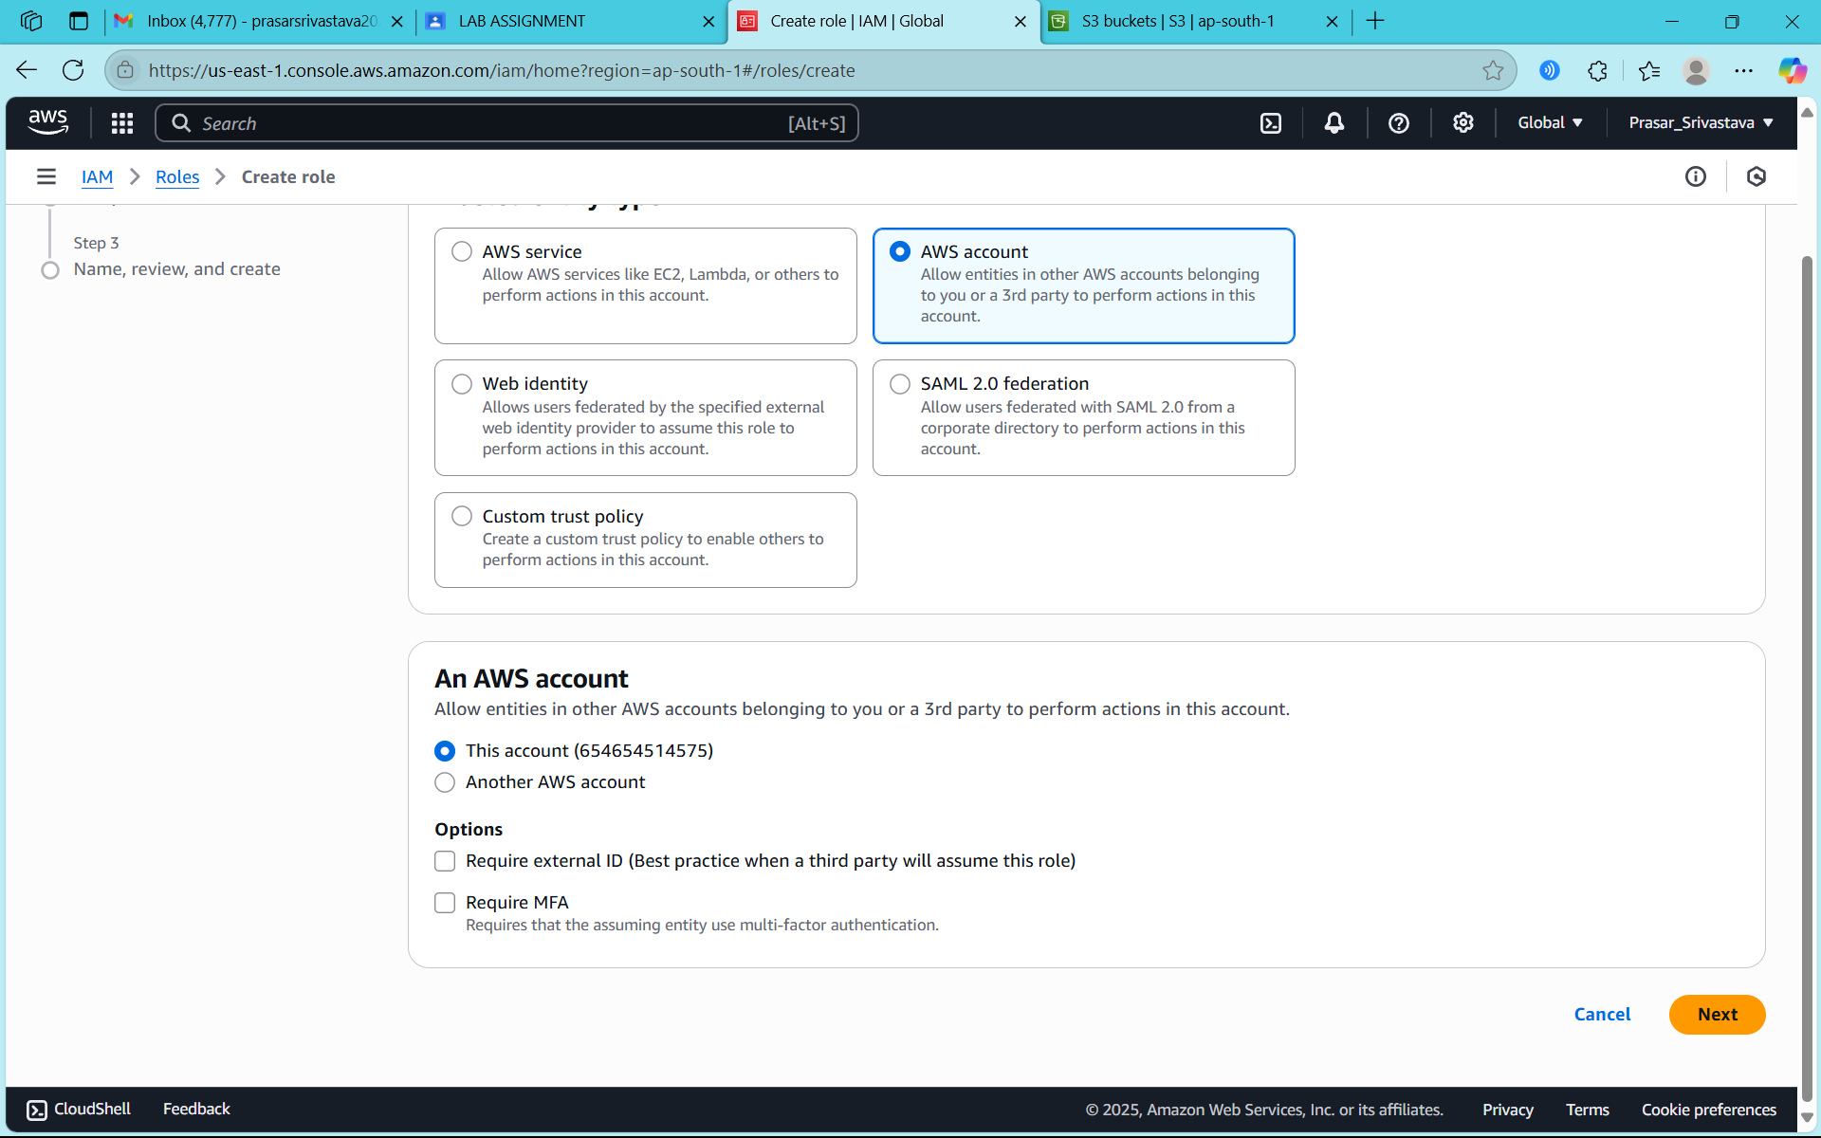

STEP5: SELECT AMAZONS3FULLACCESS POLICY

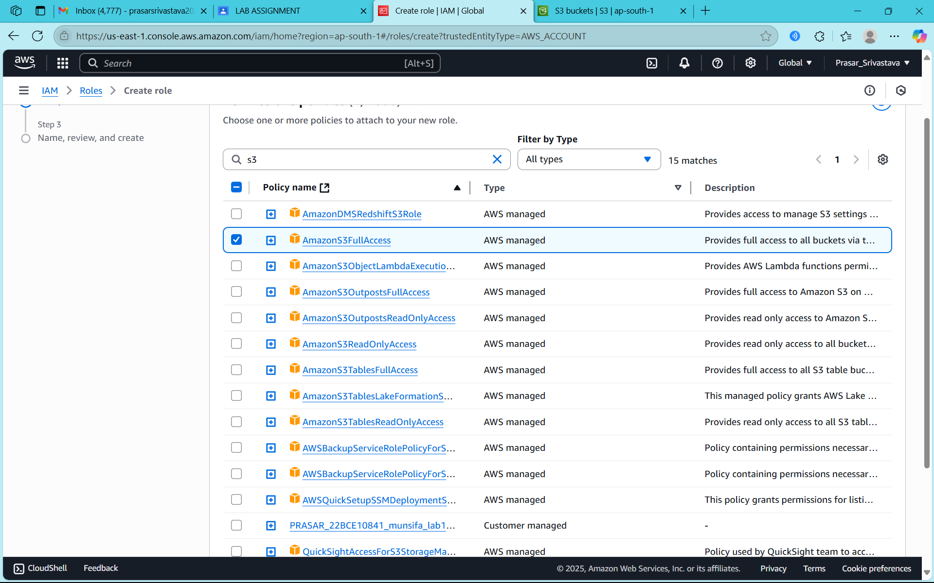

STEP6: ENTER THE ROLE NAME AND CLICK ON CREATE ROLE

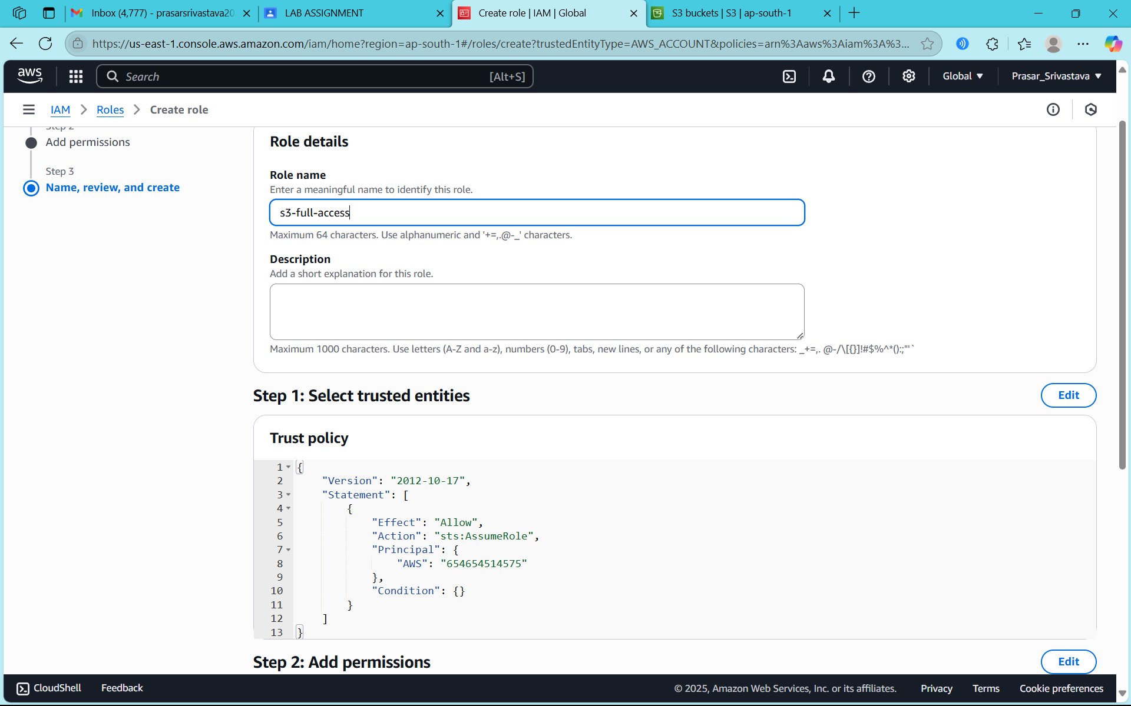

STEP7: ROLE IS CREATED

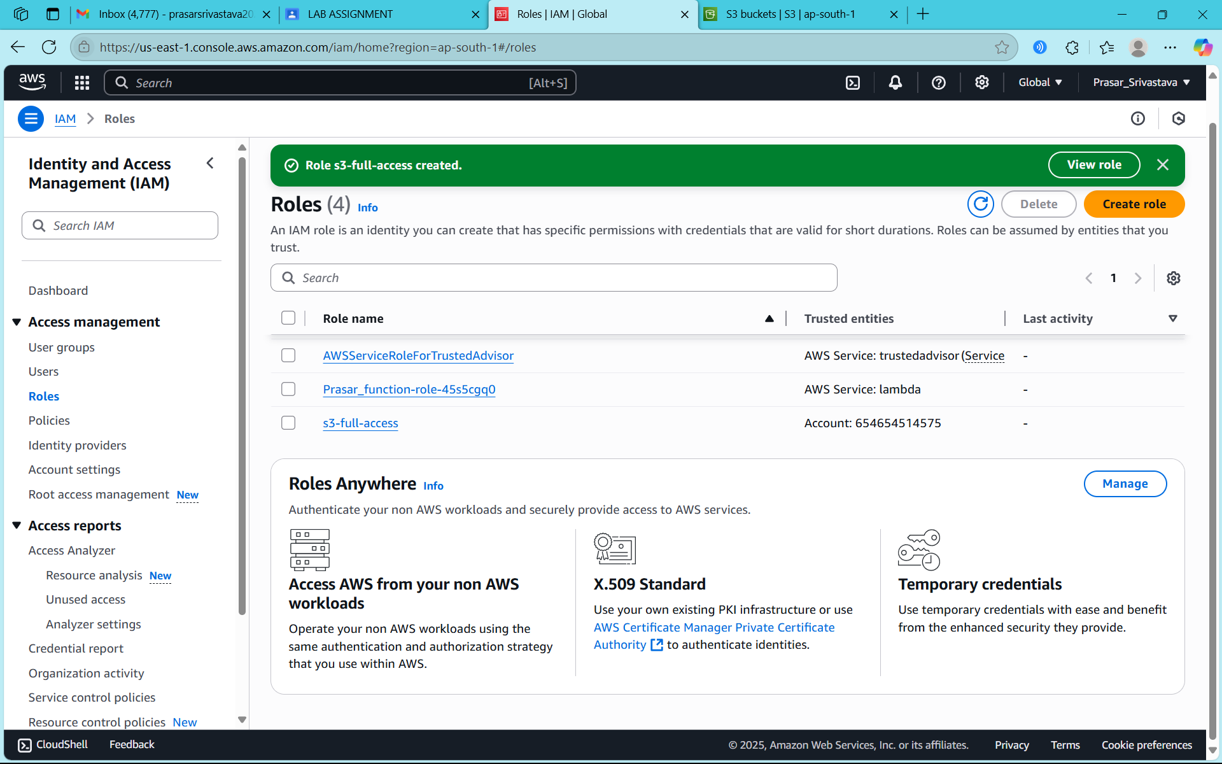

STEP8: NOW CLICK ON USERS FROM IAM DASHBOARD

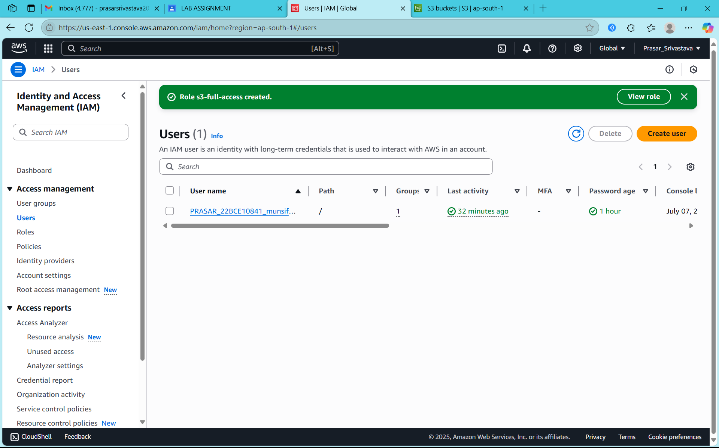

STEP9: NOW SELECT AN IAM USER WHICH YOU HAVE CREATED EARLIER

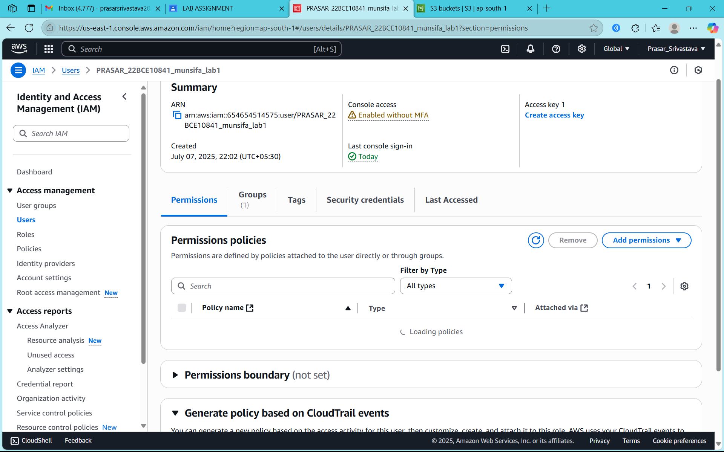

STEP10: NOW CLICK ON ADD PERMISSIONS AND CHOOSE CREATE INLINE POLICY

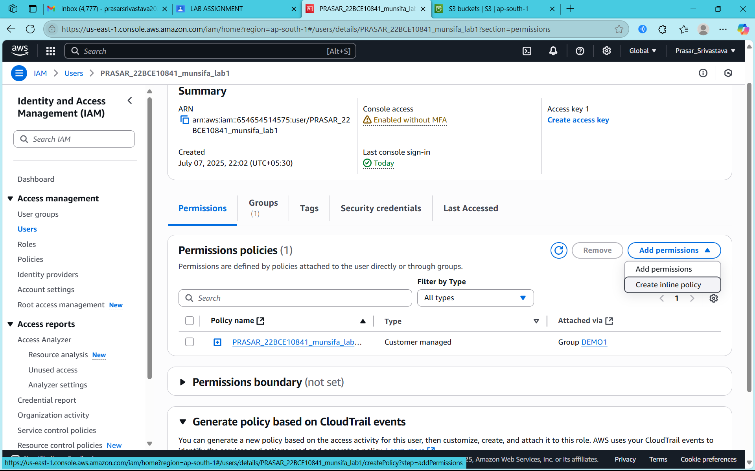

STEP11: NOW CLICK ON JSON EDITOR

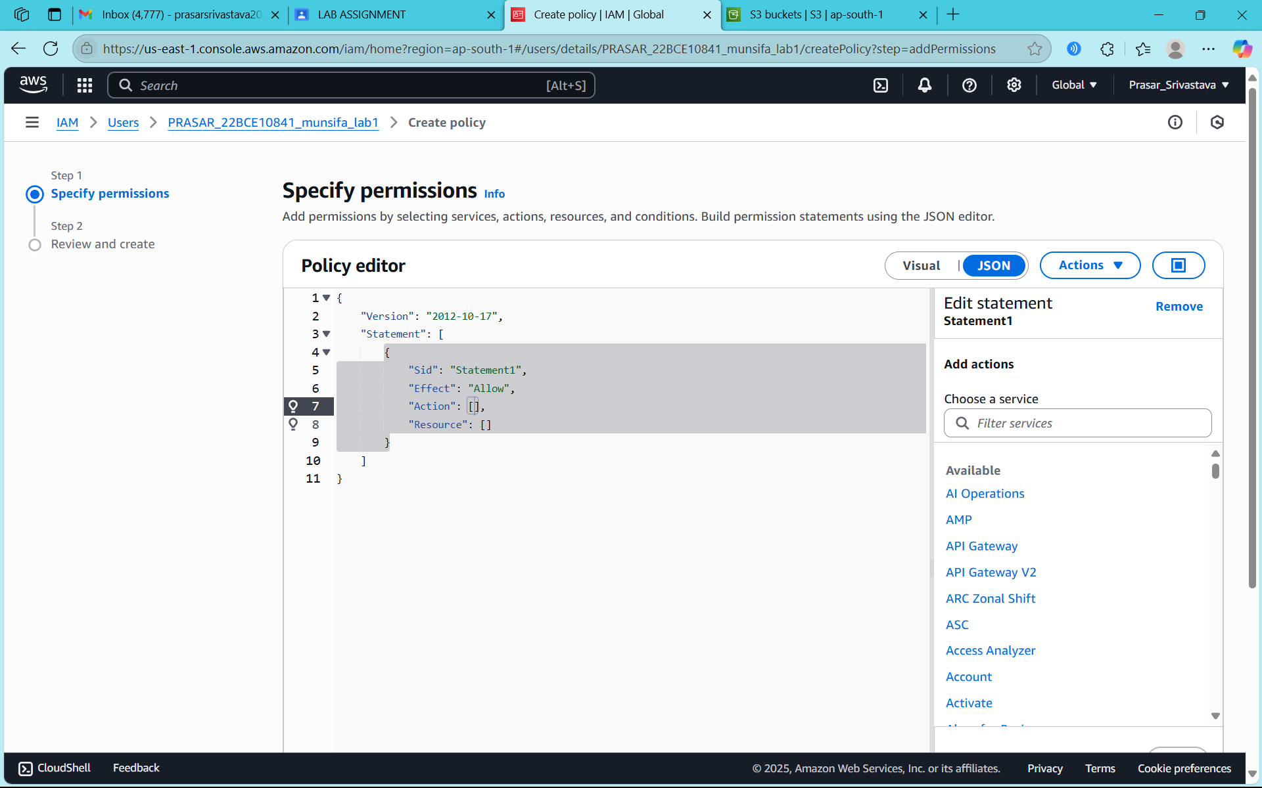

STEP12: NOW OPEN IAM DASHBOARD IN SEPARATE TAB AND CLICK ON ROLES

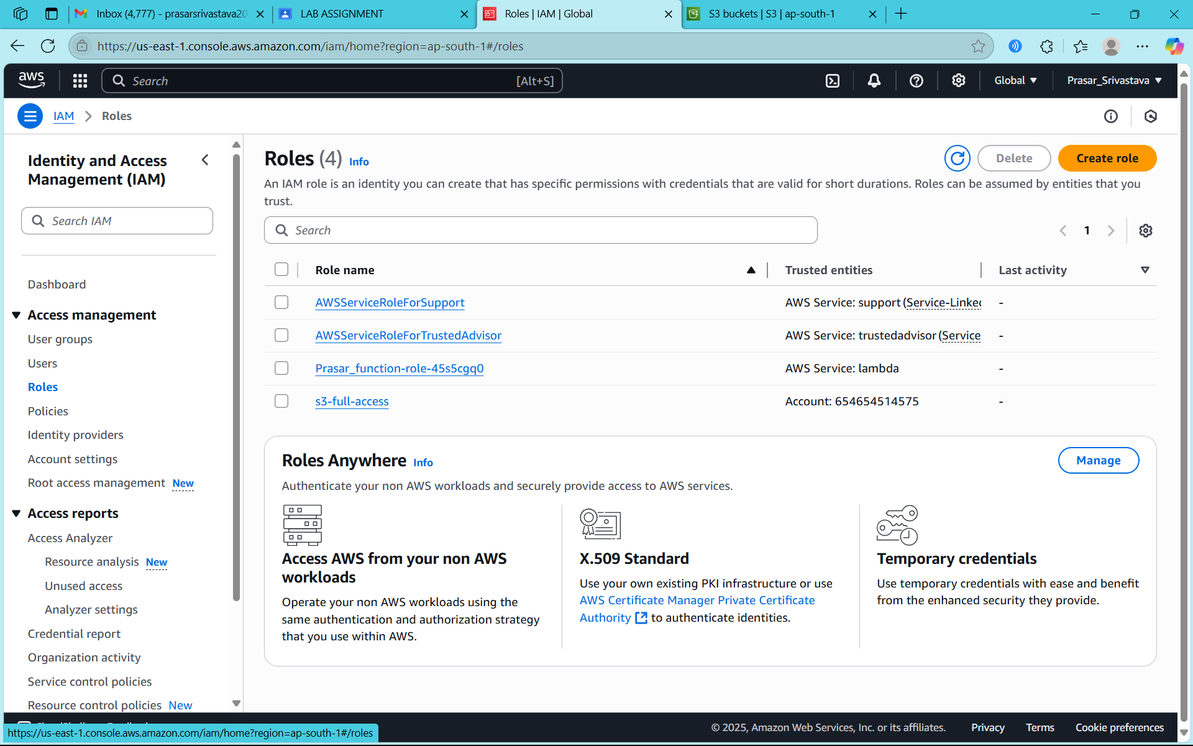

STEP13: CLICK ON THE ROLE THAT YOU HAVE CREATED AND COPY THE ARN NO

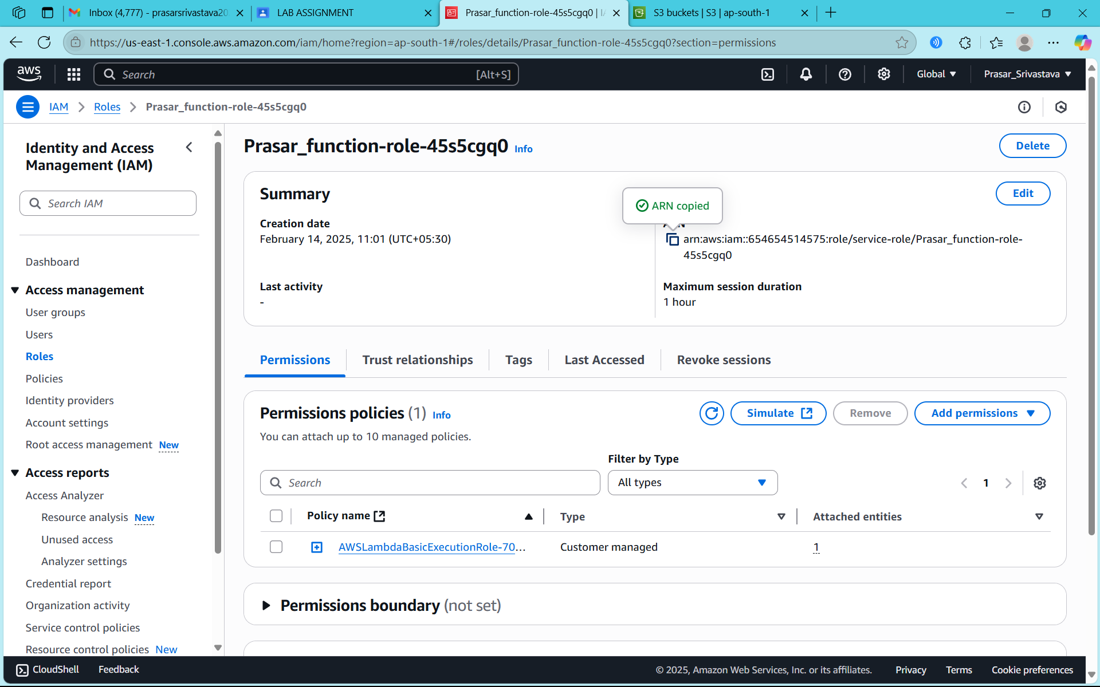

STEP14: GO TO AGAIN USER>TEST-USER>CREATE INLINE POLICY> MODIFY THE CODE (PASTE ARN IN RESOURCE)

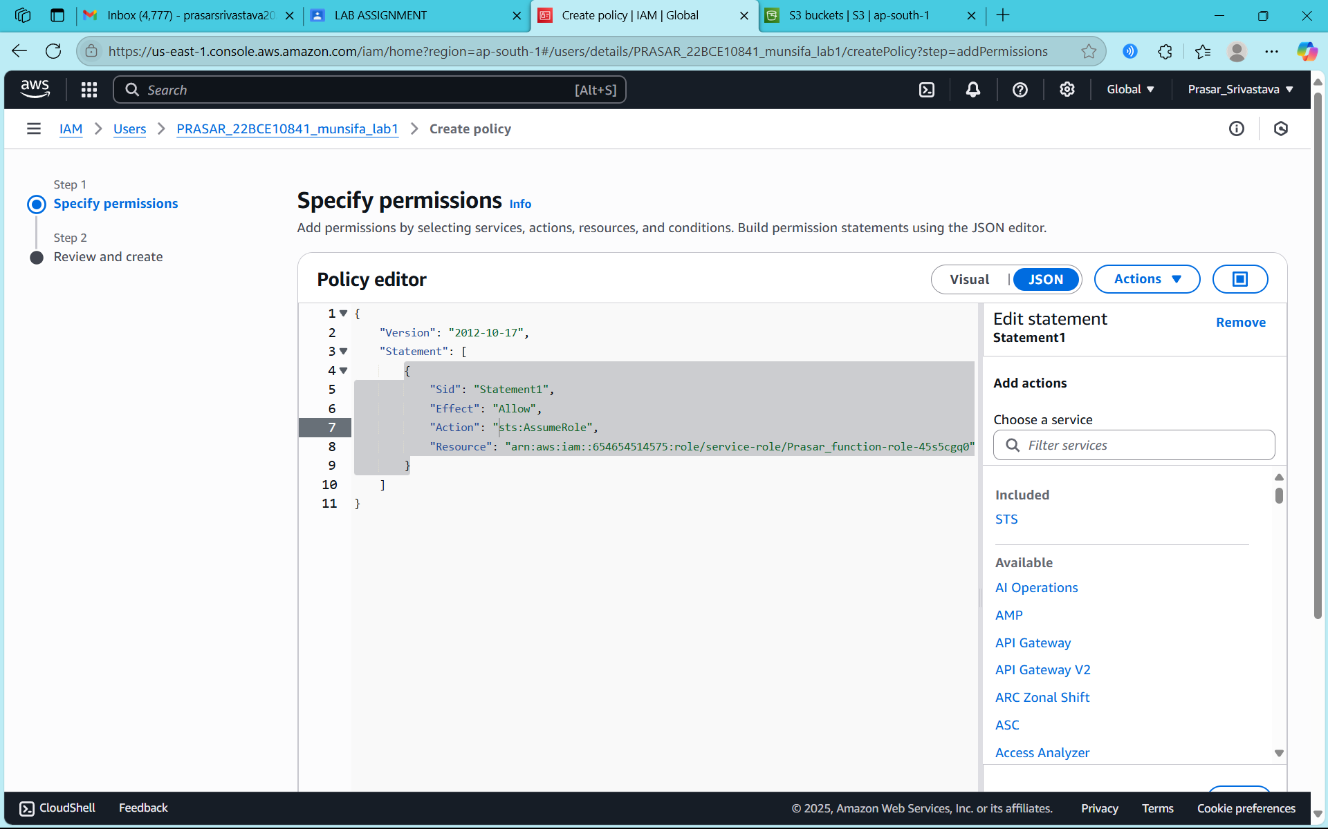

STEP15: TYPE A POLICY NAME AND CLICK ON CREATE POLICY

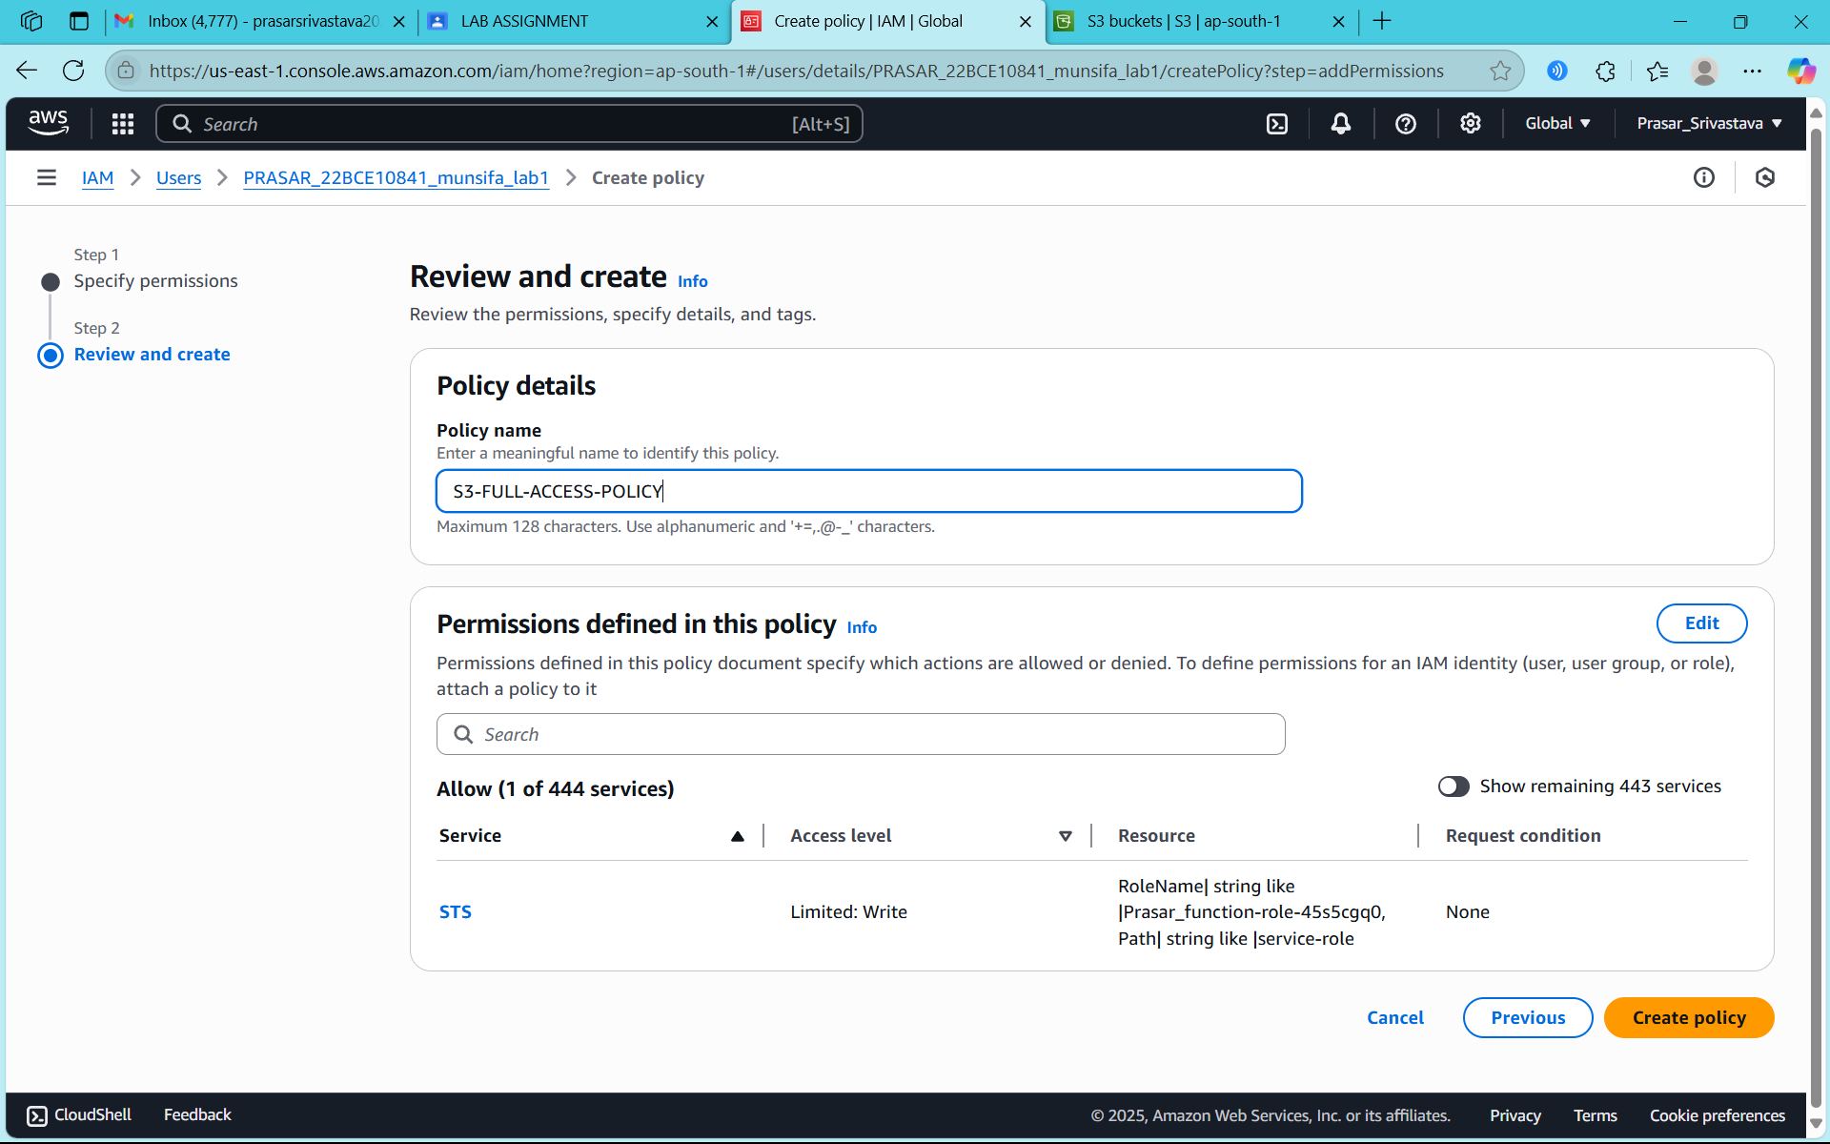

STEP16: POLICY CREATED

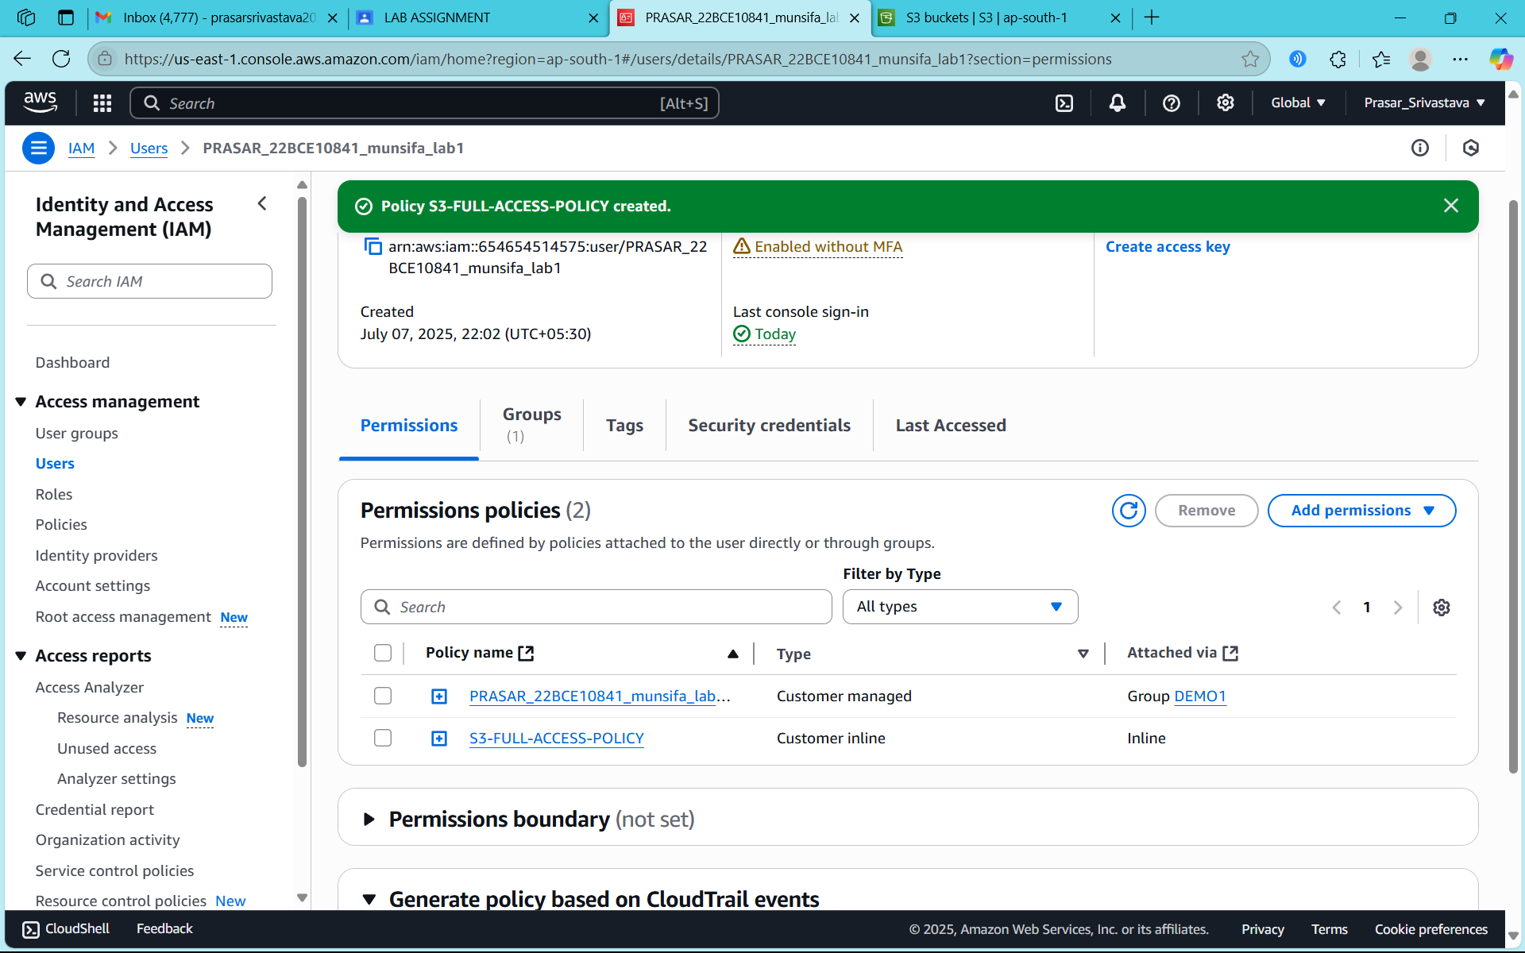

STEP17: GO TO ROLE>S3-FULL-ACCESS>COPY THE LINK FOR SWITCH USER

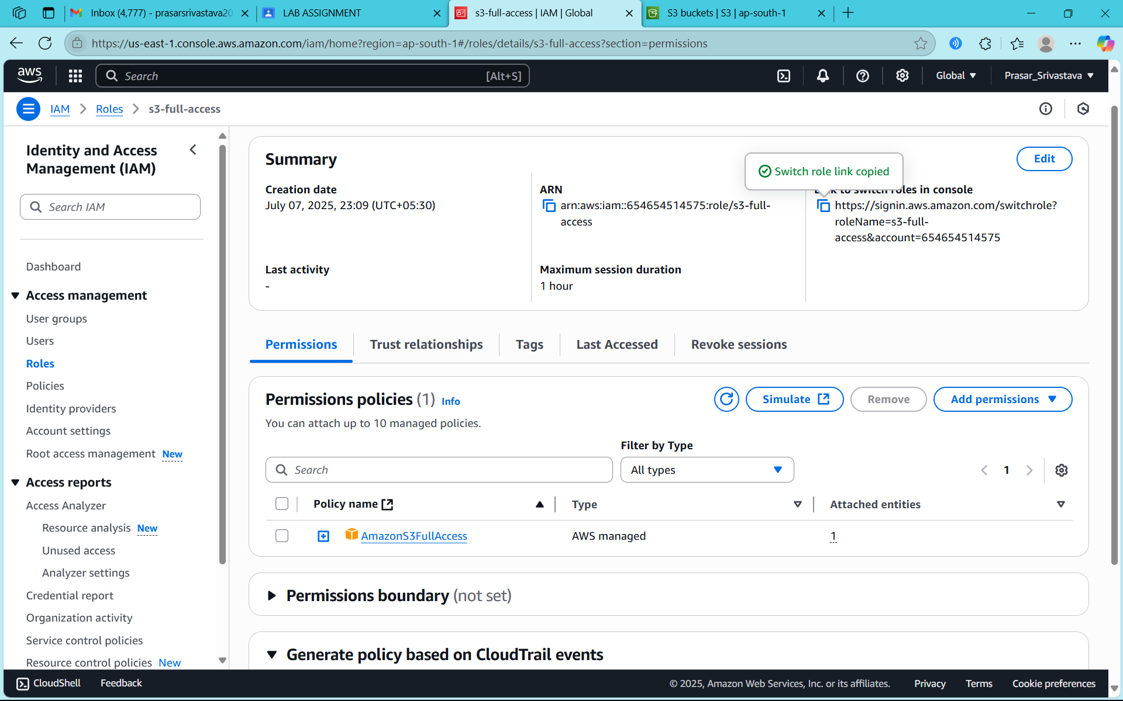

STEP18: PASTE THE LINK IN A DIFFERENT WINDOW AND CLICK ON SWITCH ROLE

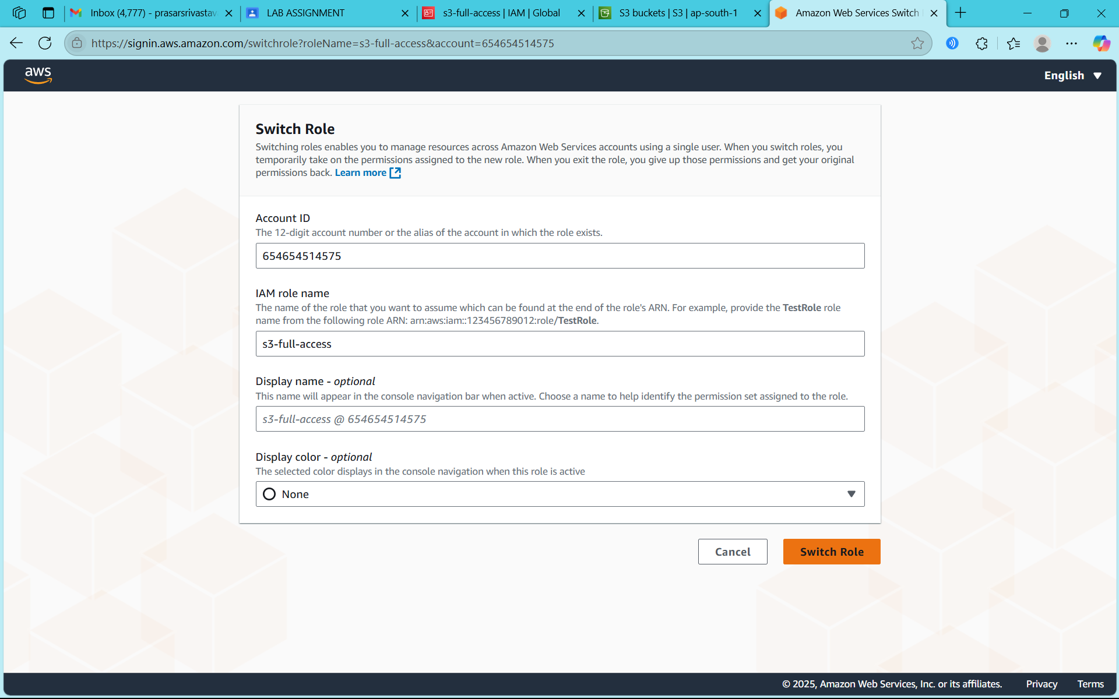

STEP19: CONSOLE PAGE FOR NEW ROLE IS DISPALYED

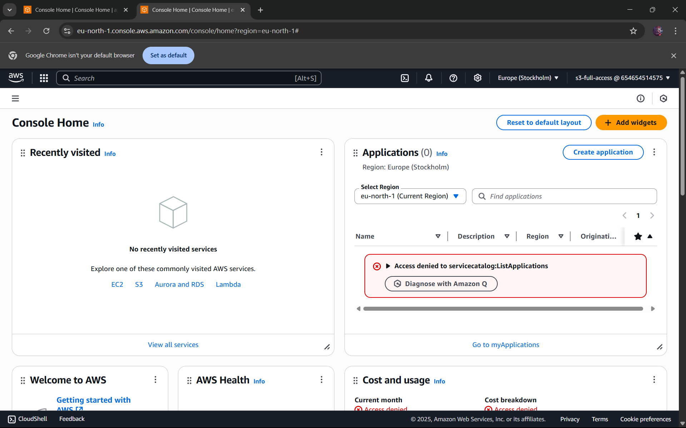

STEP20: SEARCH AND SELECT S3 DASHBOARD

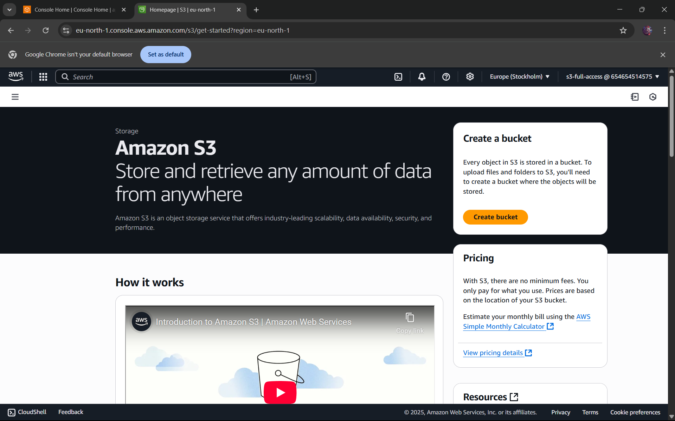

STEP21: CLICK ON GENERAL PURPOSE BUCKET

